**Development Manual**

**Team: String Cheese**

**Game: Rollerball**

**Presented by:**

Chris Schaffer

Meetkumar Savaliya

Tim Stroup

Sirius

YaHsin

**Nonfunctional Requirement**

Intellij IDEA 2018

JDK 8

**Downloads:**

1)Download **Intellij IDEA 2018** from

<https://www.jetbrains.com/student/>

2)Download **JDK 8** from

<https://www.oracle.com/technetwork/java/javase/downloads/jdk8-downloads-2133151.html>

3)Download the **GitH repository** from below link. <https://github.com/ChrisSchaffer/cs414-f18-001-stringCheese>

**Environment Setup**

**IntelliJ**

1) Double click and install Intellij.

1. Add Junit, GitHub plugins in installation time.
2. Restart the Intellij.
3. Go to **File->Project Structure(ctr+shift+alt+s)->Project SDK->click New->select path till JDK folder from computer**

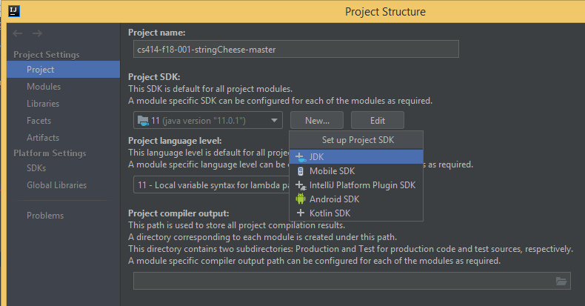

**JDK-8**

1)Double click on setup that you download.

2)Check JAVA:Open terminal and write “javac --version” and hit Enter

**Import Project:**

1. Open IntelliJ IDE
2. **Close All project from File** Menu in top left corner that will pop a “Welcome” window

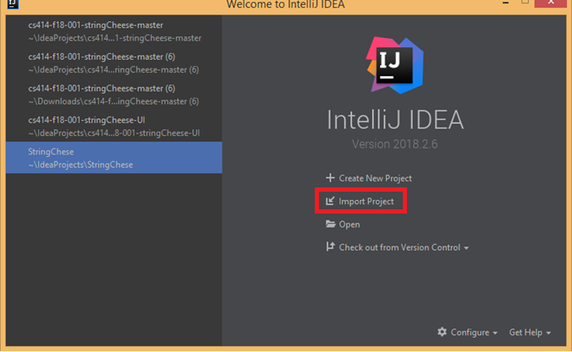

1. Select Import Project from Welcome Window.
2. Select **File destination** that you have downloaded from **GitHub.**

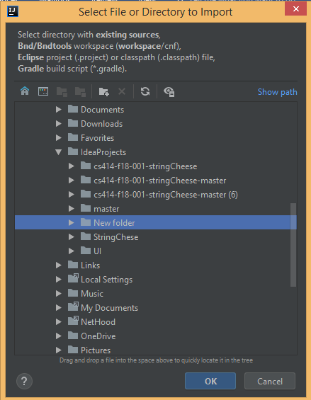

5)Click OK, Then It will ask **for create project from existing resource** and **select Eclipse**

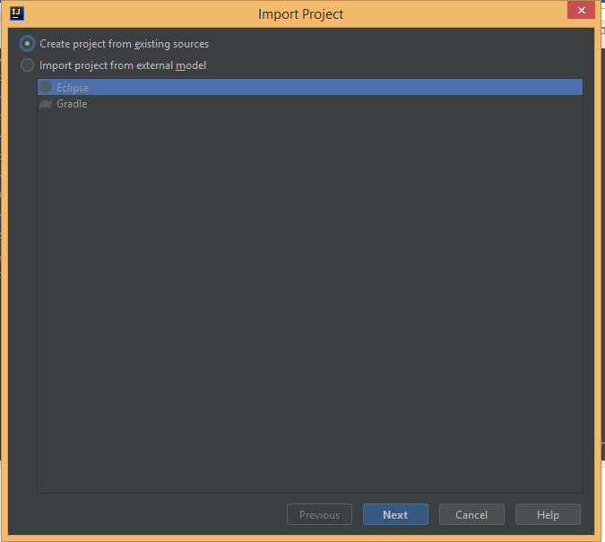

1. **Click Next**, it will automatically take project name and location

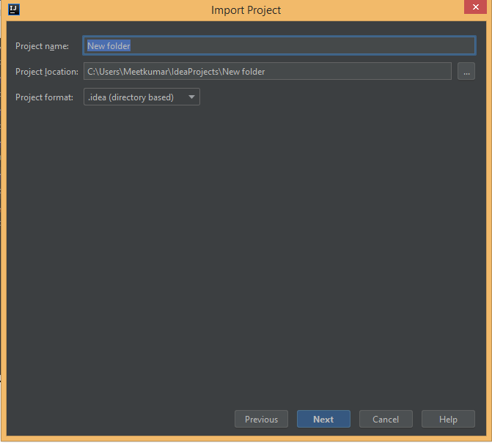

1. **Click Next**, It will detect the source file from given file location and Click **Finish**

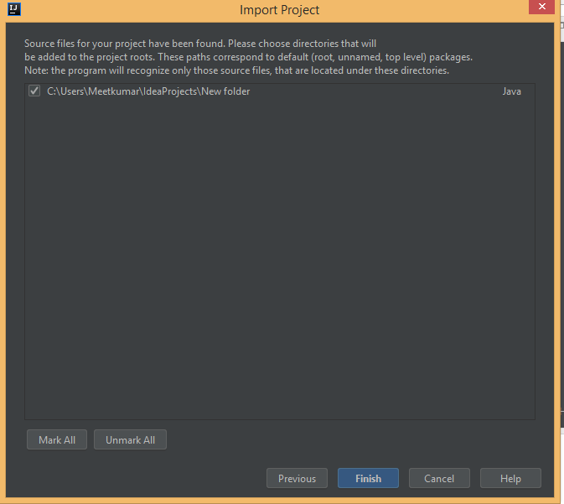

**Project Structure:**

1)Main package id edu/colostate/cs/cs414/StringCheese.

2)There are 2 folder **src and Test.**

3)src folder contain **UI package, BusinessLayer Package, Foundation Package**

4)**Test** contains all test cases

**Dependencies:**

1. In case of Junit, set curser on Junit error then press **alt+enter**

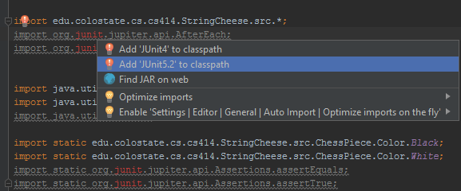

1. It will ask for Junit to **download from maven repository** then click ok

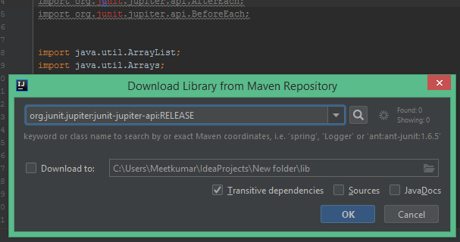

1. For third Party **JAR file** put .jar file in String-cheese(root) folder

1)javax.mail.jar

2)mysql-connector-java-8.0.13.jar

3)activation.jar

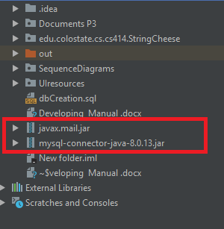

1. Set class path in project for any dependencies, **Go to File->Project Structure(ctrl+alt+shift+S)->Modules->Dependencies->Add JARs or Directories**

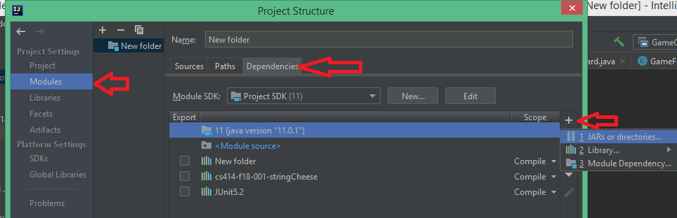

1. **Select dependency/ies** you want to add and click OK

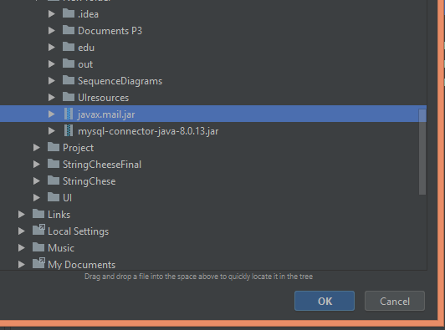

1. **Click Apply and OK** then **Build Project (ctrl+F9)** from Menu Bar

**Build Project**

1. Go to **Build** from Menu bar
2. Click **Build Project (ctrl+F9)**

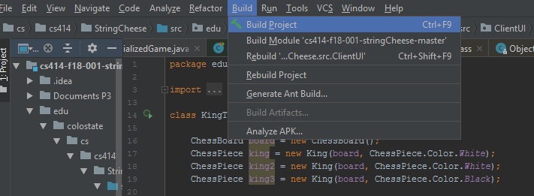

**Run the Game**

1. Run the GameClient.java from **UI Package** contain Main method of project. (For GUI)
2. Right click on **GameClient.Java->Run GameClient(ctrl+shift+F10)**

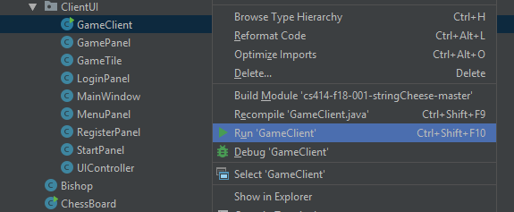

**Run the Test Cases:**

1) Main package id **edu/colostate/cs/cs414/StringCheese.**

2) There are 2 folder **src and Test.**

3) Test folder contains the All test Cases

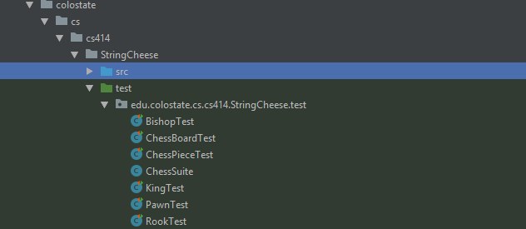

4) Click any Test Case and **Click Right-click->Run the Test** **Case(ctrl+shift+F10).**

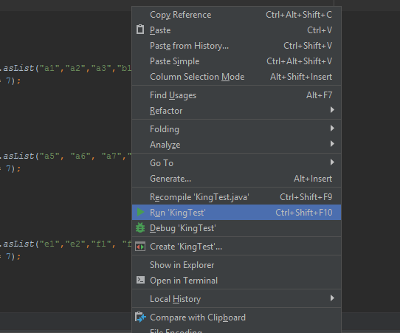

6)To Test individual method in Test cases: **Right click on the method->Run a method(ctrl+shift+F10)**

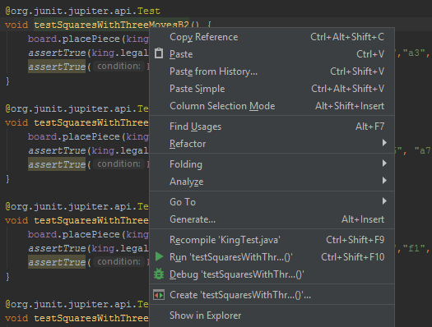

7) To test all Test cases together **Right Click on Test Folder->Run all the test (ctrl+shift+F10)**

